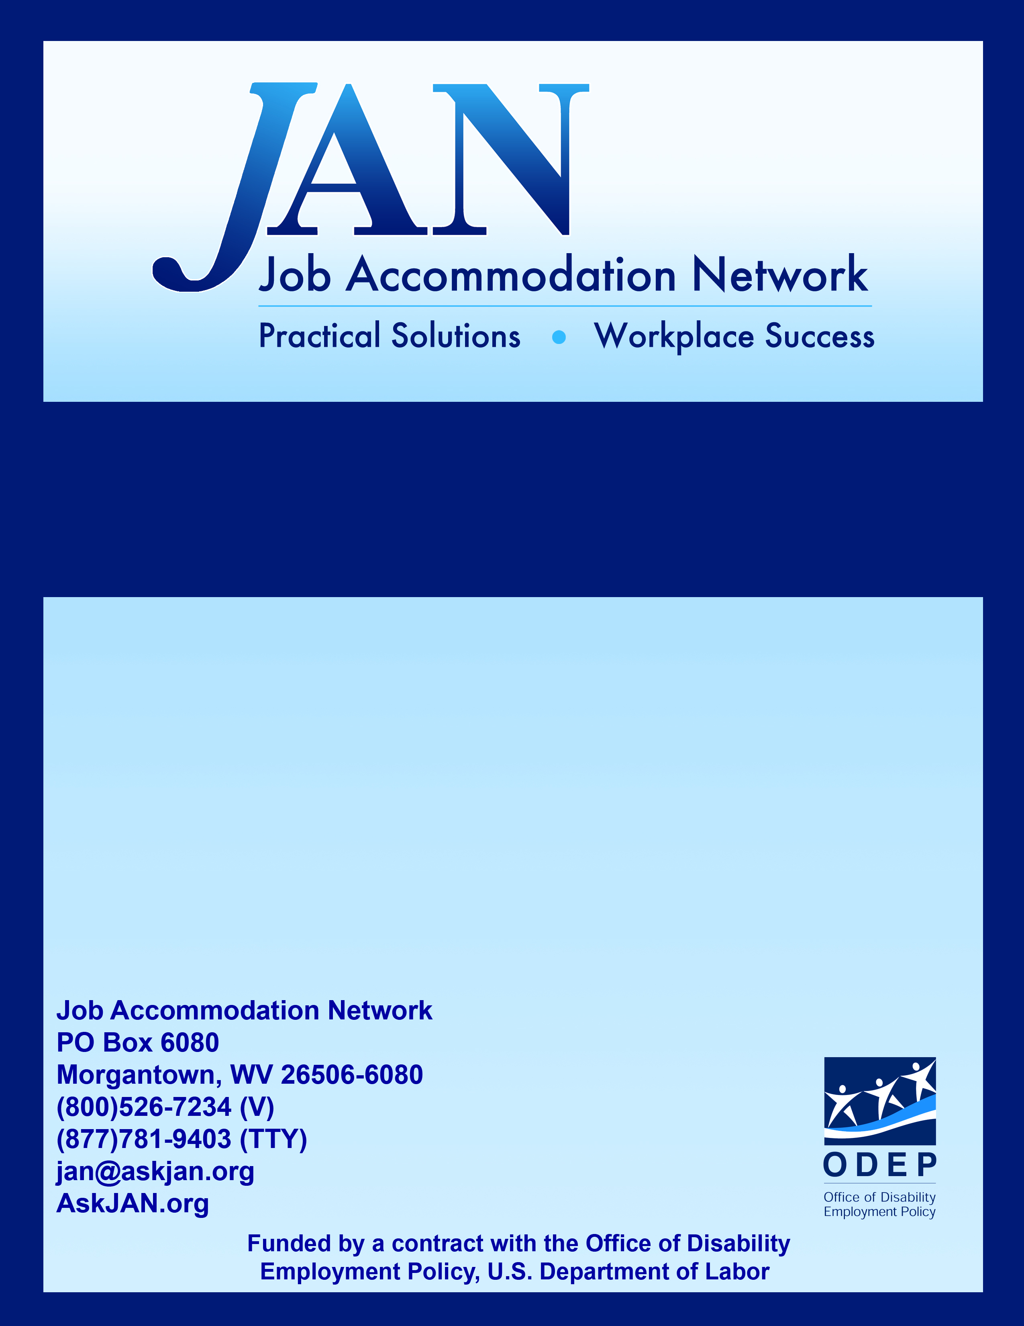
The Interactive Process:
Federal Sector

Effective Accommodation Practices (EAP) Series

JAN’S EAP SERIES

The Interactive Process

The Rehabilitation Act of 1973 requires the Federal sector to provide effective, reasonable accommodations for employees with disabilities. To help determine effective accommodations, the Equal Employment Opportunity Commission (EEOC), recommends that agencies use an “interactive process,” which simply means that employers and employees with disabilities who request accommodations work together. In addition, Executive Order 13164, which calls for the U.S. Office of Personnel Management (OPM) to work with the Department of Labor (DOL), the EEOC, and the Office of Management and Budget to design model recruitment and hiring strategies, requires all Federal agencies to establish procedures on handling requests for reasonable accommodation.

From a practical standpoint, an interactive process is a way to streamline the accommodation process and help insure that effective accommodations are provided. An effective interactive process is essential to Federal agencies in complying with Executive Order 13548. For agencies that are looking for ideas about what to include, the following is an example of what the interactive process might look like.

Step 1: Recognizing an Accommodation Request

The interactive process starts with an accommodation request from an employee with a disability so it is important for employers to be able to recognize a request. So what constitutes an accommodation request? According to the EEOC, an individual may use "plain English" and need not mention the Rehabilitation Act or use the phrase "reasonable accommodation" when requesting an accommodation. Therefore, any time an employee indicates that he/she is having a problem and the problem is related to a medical condition, the employer should consider whether the employee is making a request for accommodation under the Rehabilitation Act.

The EEOC (Reasonable Accommodation and Undue Hardship (EEOC Guidance) at http://www.eeoc.gov/policy/docs/accommodation.html) provides the following examples:

Example A: An employee tells her supervisor, "I'm having trouble getting to work at my scheduled starting time because of medical treatments I'm undergoing." This is a request for a reasonable accommodation.

Example B: An employee tells his supervisor, "I need six weeks off to get treatment for a back problem." This is a request for a reasonable accommodation.

Example C: A new employee, who uses a wheelchair, informs the employer that her wheelchair cannot fit under the desk in her office. This is a request for reasonable accommodation.
Example D: An employee tells his supervisor that he would like a new chair because his present one is uncomfortable. Although this is a request for a change at work, his statement is insufficient to put the employer on notice that he is requesting reasonable accommodation. He does not link his need for the new chair with a medical condition.

Tips:

- Err on the side of caution: If an employer is not sure whether an employee has requested an accommodation, the employer should ask the employee to clarify what is being requested and why.

- Act quickly: Once an accommodation request is identified, the employer should respond immediately – unnecessary delays in processing an accommodation request can violate the Rehabilitation Act.

- Assign responsibility: Employers should assign at least one person who is responsible for making sure an accommodation request is processed so the request is not lost on someone’s desk.

- Conduct training: Employers should train all managers and supervisors to recognize accommodation requests and what to do with a request once it is received.

Step 2: Gathering Information

Once an accommodation request has been received, the employer should gather whatever information is necessary to process the request. Necessary information may include documentation of the disability and need for accommodation. In some cases, the employee’s disability and need for accommodation are obvious and no additional information is needed. For example, if an employee who recently started using a wheelchair indicates that he needs a ramp to get into the workplace, the disability and need for accommodation are obvious.

However, in other cases the individual may know that he/she is having difficulty, but may be uncertain about the exact cause or possible solution. For example, if an employee with a non-visible disability indicates she is having trouble completing her work tasks because of her disability, the employer does not have enough information to provide effective accommodations. The employer needs to know what limitations are interfering with job performance and what specific work tasks are at issue.

So how should an employer get the information that is needed? The employee who requested the accommodation is often the best source of information about the disability and possible accommodations. If the employee cannot provide the necessary information, then medical documentation can be useful. The important thing for employers to remember is not to ask for too much information. Under the Rehabilitation Act, when an employee requests an accommodation and the disability and need for accommodation are not obvious, then the employer can request medical documentation to help determine whether the employee has a disability and needs the requested accommodation and information to help process the accommodation request.

Tips:

- Find out the limitation and problem. In most cases, to find effective accommodations employers need to know what limitation is causing what problem so this is usually a good place to start.

- Get information from the employee when possible. Employees with disabilities are familiar with their limitations and often know what accommodations will work best for them.

- Remember Rehabilitation Act rules for medical inquiries. A good policy for employers is to only ask for what is absolutely necessary. Asking for all medical records will rarely, if ever, meet this test.

Step 3: Exploring Accommodation Options

Once the employer has identified the employee’s limitation that is causing a problem and has identified what that problem is, then the employer is ready to explore accommodation options. At this step, employers should be open to new ideas and new ways of doing things. This is the time to brainstorm and consider what might work.

Again, the employee who requested the accommodation is a good place to start so employers should always invite the employee to suggest accommodations. If more accommodation ideas are needed, the employer can ask the employee’s medical provider for ideas – in some cases medical professionals are able to suggest effective accommodations. In other cases, they may not be able to suggest ideas, but may be able to say whether ideas under consideration will help overcome the employee’s limitations.

And if still more ideas are needed, then the employer should consult with outside resources such as JAN, vocational rehabilitation, rehabilitation engineers, and disability-related organizations. Remember when consulting with outside resources, employers must comply with the confidentiality rules of the Rehabilitation Act. One good approach is to withhold the employee’s name and identifying information from outside resources.

Tips:

- Keep an open mind. Accommodations are about doing things differently to help overcome disability-related limitations, so keep an open mind when exploring accommodation options.

- Invite the employee to suggest accommodations. The employee who requested the accommodation may have some good accommodation ideas, but may be hesitant to bring them up without being asked to do so.

- Ask the employee’s medical provider for ideas. Some medical professionals will brainstorm accommodation ideas with employers.

- Use JAN when needed. JAN is a free, national resource for employers who are seeking help coming up with accommodation ideas.

Step 4: Choosing an Accommodation

Once accommodation options have been explored, the employer must choose what accommodation to implement. If there is more than one option, the employer should consider the preference of the employee. However, the employer gets to choose among effective options and can choose, for example, the lowest cost accommodation.

Sometimes employers are not sure whether an accommodation will work and are afraid if they try it out they will be locked in forever. This is not the case – employers are free to try accommodations and stop them if they do not work. One thing employers might want to do when testing accommodations is to make a written agreement with the employee that the accommodation is being tested, how long the test will be, and what will happen if the accommodation does not work. That way, no one is surprised when the accommodation is revisited down the road.

Tips:

- Consider the employee’s preference. Although not required by the Rehabilitation Act, when possible employers should choose the accommodation the employee prefers.

- Consider a trial period. When it is not clear whether an accommodation will work, it might be possible to try out the accommodation.

Step 5: Implementing the Accommodation

Once an accommodation has been chosen, it is time to implement the accommodation. This step is very important to the success of an accommodation. If equipment is involved, then it needs to be properly installed and the employee needs to be trained in its proper use. If the accommodation involves a schedule change or policy modification, then certain managers or supervisors may need to know of the change to effectively implement it. If the accommodation involves an outside service, someone needs to make sure the service is provided promptly and effectively. If the accommodation is a reassignment, then the employee may need time to acclimate to the new job.

Tips:

- Make sure all necessary steps are taken to implement the accommodation. A good way to do this is to check to see if the accommodation is actually working.

- Communicate with essential personnel about the accommodation. Remember Rehabilitation Act confidentiality rules and only let managers and supervisors know about the accommodation if necessary.

Step 6: Monitoring the Accommodation

An important but often forgotten part of the interactive process is monitoring accommodations after they are in place. In some cases, an accommodation stops being effective for various reasons such as: the employee’s limitations change, workplace equipment changes, the job changes, the workplace itself changes, or the accommodation becomes an undue hardship for the employer.

Because changes occur, employers may need to periodically check on the ongoing effectiveness of accommodations. If equipment is involved in the accommodation, someone may need to be assigned to perform maintenance or upgrades as needed. The most important way to monitor accommodations is to encourage ongoing communication. Employees who are receiving accommodations need to understand that they should let their employers know if there are changes or problems with the accommodation and who specifically to contact.

Tips:

- Check on effectiveness. As things change in the workplace, accommodations may need to also change so employers should periodically check the effectiveness of accommodations.

- Maintain the accommodation. Equipment will not function forever without maintenance so when equipment is part of an accommodation, employers need to make sure the equipment is properly maintained.

- Encourage ongoing communication. For any workplace issue, ongoing communication is the key to success. The same is true for accommodations – employers should encourage employees to communicate any issues they have with their accommodations.

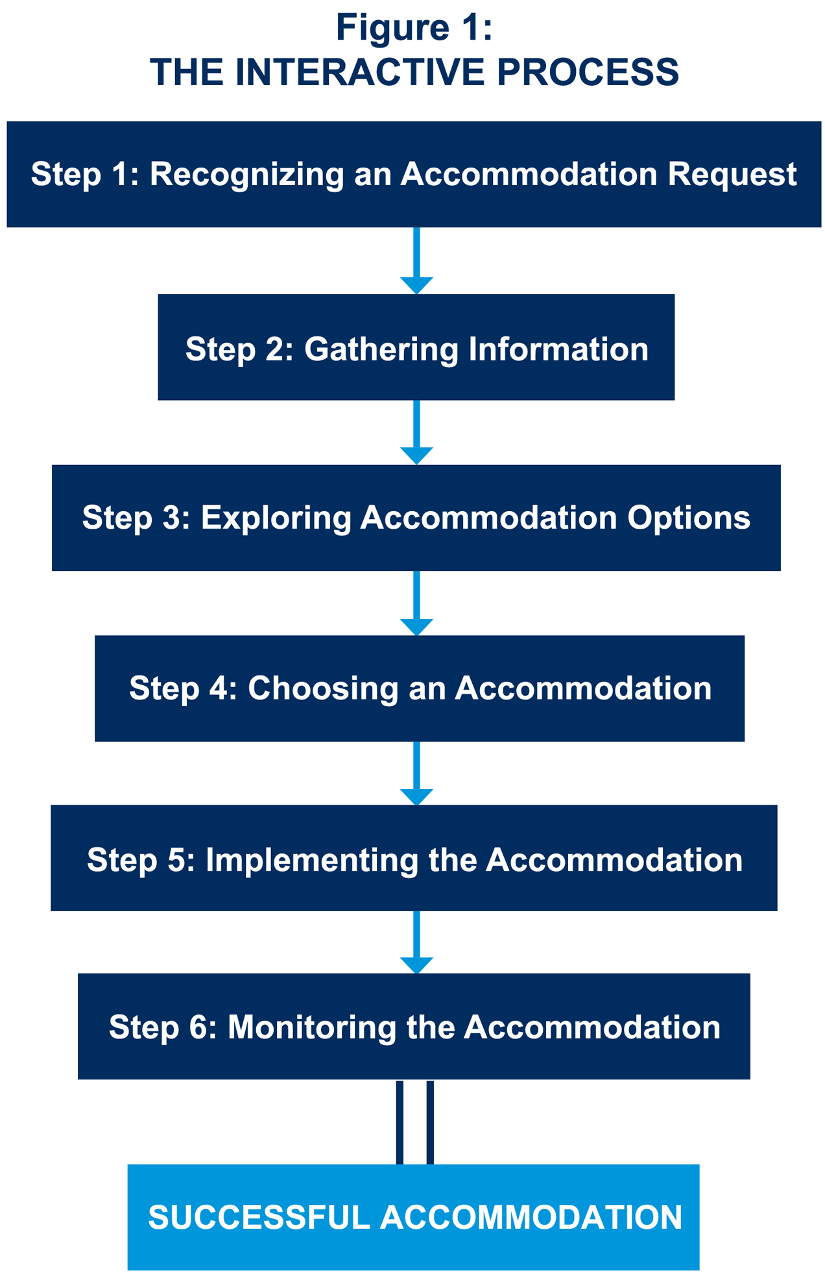

Federal agencies have several documents and resources available to assist with the interactive process:

DOCUMENTS

EEOC
EEOC's Procedures for Providing Reasonable Accommodation for Individuals with Disabilities is available to agencies to assist in establishing procedures and handling requests for reasonable accommodation. Locate these procedures at http://www.eeoc.gov/eeoc/internal/reasonable_accommodation.cfm. Additional EEOC Guidances, fact sheets, reports, and advisory letters are available at: https://AskJAN.org/resources/U-S-Equal-Employment-Opportunity-Commission.cfm

JAN
JAN's A to Z of Disabilities and Accommodations are Websites available to provide accommodation ideas and links to information on various impairments and accommodations and other Rehabilitation Act issues. For more information on these topics, go to: https://AskJAN.org/a-to-z.cfm

RESOURCES AND PROGRAMS

Office of Disability Employment Policy (ODEP), U.S. DOL
ODEP provides national leadership on disability employment policy by developing and influencing the use of evidence-based disability employment policies and practices, building collaborative partnerships, and delivering authoritative and credible data on employment of people with disabilities. For more information on ODEP, go to: http://www.dol.gov/odep/

Department of Defense's Computer/Electronic Accommodations Program (CAP)
CAP's mission is to insure that people with disabilities and wounded service members have equal access to the information environment and opportunities in the DoD and throughout the Federal government. For more information on CAP, go to: http://www.cap.mil

Schedule A
Using the Schedule A appointing authority, found at 5 CFR § 213.3102(u), qualified candidates who meet the OPM guidelines can be hired non-competitively without the typical recruitment requirements and without posting and publicizing the position. For more information on Schedule A, go to: https://hru.gov/Studio_Recruitment/HT_05_Schedule_A_-_Individuals_With_Disabilities.aspx

Workforce Recruitment Program (WRP)
Co-sponsored by the U.S. DOL’s ODEP and the DoD with the participation of many other Federal agencies, the WRP is a recruitment and referral program that connects Federal sector employers nationwide with highly motivated postsecondary students and recent graduates with disabilities who are eager to prove their abilities in the workplace through summer or permanent jobs. For more information on WRP, go to: http://www.wrp.gov

U.S. Department of Agriculture's TARGET Center
The TARGET Center's mission is to insure that all USDA employees have safe and equal access to electronic and information technology by assessing, educating, and advocating for the integration of assistive technology and worksite accommodations. For more information on the TARGET Center, go to: http://www.dm.usda.gov/oo/target/index.html

U.S. DOL's Central Office for Assistive Services and Technology (COAST)
COAST serves as a one-stop-shop, within the Conference and Service Center (CSC) for disability related needs. Managers, employees, and applicants of DOL can obtain guidance, counsel, and information on reasonable accommodations, related services, issues, and organizations for and about people with disabilities. For more information on COAST, go to: http://www.dol.gov/oasam/programs/crc/rarc.htm

U.S. DOL's Veterans' Employment & Training Service (VETS)
VETS provides resources and expertise to assist and prepare veterans and service members to obtain meaningful careers, maximize their employment opportunities, and protect their employment rights. For more information on veterans resources, go to: http://AskJAN.org/topics/veterans.htm

JAN
For more information on Federal accommodation programs and the Federal employment of people with disabilities, go to: https://AskJAN.org/topics/Federal-Employment-of-People-with-Disabilities.cfm

Updated 05/31/2018.

This document was developed by the Job Accommodation Network, funded by a contract from the U.S. Department of Labor, Office of Disability Employment Policy (#1605DC-17-C-0038). The opinions expressed herein do not necessarily reflect the position or policy of the U.S. Department of Labor. Nor does mention of tradenames, commercial products, or organizations imply endorsement by the U.S. Department of Labor.

